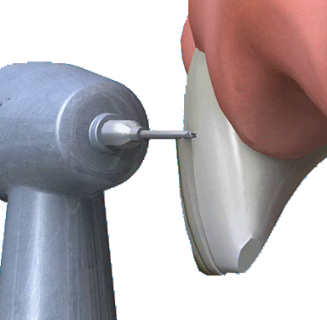
VENEERS

Q What is a veneer?

A A veneer is a thin layer of porcelain made to fit over the front surface of a tooth, like a false fingernail fits over a nail. Sometimes a natural colour ‘composite’ material is used instead of porcelain.

Q What are the advantages of veneers?

A Veneers make teeth look natural and healthy, and because they are very thin and are held in place by a special strong bond (rather like super-glue) very little preparation of the tooth is needed.

Q When would I need a veneer?

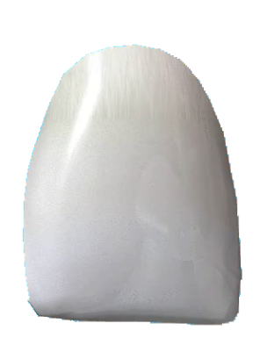
A Veneers can improve the colour, shape and position of teeth. A precise shade of porcelain can be chosen to give the right colour to improve a single discoloured or stained tooth or to lighten front teeth (usually the upper ones) generally. A veneer can make a chipped tooth look intact again. The porcelain covers the whole of the front of the tooth with a thicker section replacing the broken part. Veneers can also be used to close small gaps, when orthodontics (braces) are not suitable. If one tooth is slightly out of position, a veneer can sometimes be fitted to bring it into line with the others.

Q What about alternatives?

A A natural-coloured filling material can be used for minor repairs to front teeth. This is excellent where the tooth supports the filling, but may not work so well for broken tooth corners. There will always be a join between the tooth and the filling material.

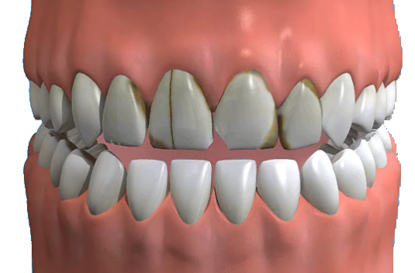
Crowns are used for teeth that need to be strengthened – either because they have broken, have been weakened by a very large filling, or have had root canal treatment.

Q How long will a veneer last?

A Veneers should last for many years, but they can chip or break, just as your own teeth can. Your dentist will tell you how long each individual veneer should last. Small chips can be repaired, or a new veneer fitted if necessary.

Q How are teeth prepared for a veneer?

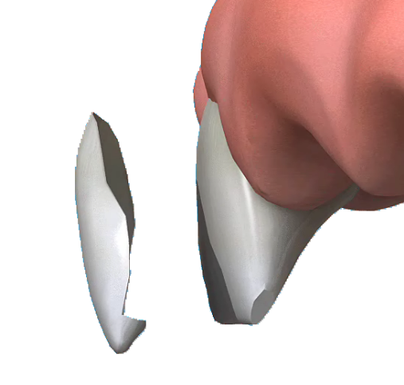
A Some of the shiny outer enamel surface of the tooth may be removed, to make sure that the veneer can be bonded permanently in place later. The amount of enamel removed is tiny and will be the same as the thickness of the veneer to be fitted, so that the tooth stays the same size. A local anaesthetic (injection) may be used to make sure that there is no discomfort, but often this is not necessary. Once the tooth has been prepared, the dentist will take an ‘impression’. This will be given to the dental technician, along with any other information needed to make the veneer. The colour of the surrounding teeth is matched on a shade guide to make sure that the veneer will look entirely natural.

Q How long will it take?

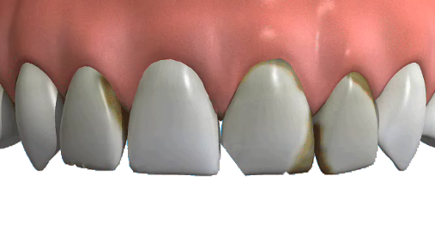
A A veneer takes at least two visits; the first to prepare the tooth and to match the shade, and the second to fit it. Before bonding it in place, your dentist will show you the veneer on your tooth to make sure you are happy with it. Bonding a veneer in place is done with a special adhesive, which holds it firmly on the tooth.

Q Will I need a temporary veneer between visits?

A Because the preparation of the tooth is so slight you will probably not need a temporary veneer. The tooth will look very much the same after preparation, but will feel slightly less smooth.

Q What happens after the veneer is fitted?

A Only minor adjustments can be made to the veneer after it is fitted. It is usually best to wait a little while to get used to it before any changes are made. Your dentist will probably want to check and polish it a week or so after it is fitted, and to make sure that you are happy with it.

Q How much will it cost?

A You can have veneers on the NHS. However, many dentists prefer to provide cosmetic treatment privately. It is important to discuss charges and treatment options with your dentist before starting treatment.

